

Bone Metastases

What are Bone Metastases?
Nearly all types of cancers can metastases to the bones, however bone metastases are most common in patients with advanced solid tumors, including prostate and breast (65-75% of patients) and those affecting the lung (30-40%) and kidney (20-32%). Bone metastasis can occur in any bone, however they more commonly occur in the spine, pelvis, ribs, skull, upper arm, and long bones of the leg. They may be the first sign of cancer, or may occur years after cancer treatment. Early detection of skeletal metastasis is critical for accurate staging and optimal treatment. Many patients with bone metastases will develop skeletal-related events (SREs), including pathologic fracture, spinal cord compression, myelosuppression, and hypercalcemia. SREs have been shown to be associated with moderate/severe pain, opioid analgesic use, reduced emotional well-being, and decreased survival.
What are the Symptoms of Bone Metastases?
- Bone pain is the most common symptom
- Bones can become weak, which may lead to fractures
- Urinary incontinence
- Bowel incontinence
- If a tumor compresses on the spinal cord, a person may feel weakness or numbness in the legs, arms or abdomen
- Bones damaged by cancer may also release high levels of calcium into the blood, called hypercalcemia, causing nausea, fatigue, thirst, frequent urination, and confusion
- Decreased weight bearing on lower extremity

How are Bone Metastases Detected?
Bone metastases may be found when the primary cancer is diagnosed or if the patient is having specific symptoms. Imaging that may be recommended include: x-rays, bone scans, computerized tomography (CT) scans, positron emission tomography (PET) scans, and magnetic resonance imaging (MRI) scans. Laboratory tests may be used to check blood or urine for high levels of substances that are released into the body by damaged bones. Further, a bone biopsy can be done to confirm the bone metastases.

What are the Different Types of Bone Metastases?
- Osteolytic lesions: are characterized by destruction of normal bone, present in multiple myeloma (MM), renal cell carcinoma, melanoma, non-small cell lung cancer, non-hodgkin lymphoma, or thyroid cancer. The great majority of BC produces osteolytic metastases.
- Osteoblastic lesions (or sclerotic): are characterized by deposition of new bone, present in prostate cancer, carcinoid, small cell lung cancer, Hodgkin lymphoma or medulloblastoma. The mechanisms of osteoblastic metastases are still poorly understood, leaving the bone fragile but not as weak as osteolytic lesions.
Mixed lesion: if patients have both osteolytic and osteoblastic lesions, which are common in breast cancer, gastrointestinal cancers and squamous cancers.

How are Bone Metastases Treated?
Treatment aims to stop or slow the growth of a tumor, prevent further bone damage, and manage pain or other varied symptoms. Treatment options will depend on several parameters, for example, if bone metastases is widespread, if there is evidence of extraskeletal metastases, the location, type and number of tumors, the person's overall health, and which treatments have been previously received. They may often shrink or slow the growth of bone metastases and can help with the symptoms they are causing. Unfortunately, they are not curative.
- Radiotherapy: is one of the most common forms of treatment for bone metastases, used to help relieve pain and strengthen the bone.
- Bisphosphonates: bone-modifying agents which help slow bone thinning, reduce pain, and decrease hypercalcemia.
- Surgery: may be used to remove a tumor, prevent (prophylatically) a bone fracture, or treat a bone fracture. Various orthopedic procedures exist to help stabilize the bone.
Chemotherapy, hormone therapy, and the use of radioactive drugs are treatment options if bone metastases are found in more than one area.

What is New in Physiotherapy and Bone Metastases?
A recent poster presentation at The 2nd National Knowledge Translation Conference in Rehabilitation outlined in a quality improvement research project carried out by clinicians, researchers, McGill PT/OT students and patient education specialists, including a medical writing expert and medical illustrator titled: Development of an Evidence-based Educational Resource for Implementation in Oncology Rehabilitation.
Outlined below is a summary of the project and a small sample of the booklet pending final edits prior to publication.
Cancer patients with bone metastases are at high risk of pathological fractures, however are frequently not equipped with fracture prevention strategies. Given the advances in cancer treatment and that patients with bone metastasis are living longer, an educational resource is needed to complement clinical care, in order to minimize the occurrence of preventable fractures.
The objective was to create an evidence-based educational resource for patients with bone metastases, for implementation in oncology rehabilitation.
This quality improvement research project was carried out, involving collaboration among clinicians, researchers and patient education specialists, including a medical writing expert and a medical illustrator. A comprehensive literature review on fracture prevention strategies, as well as clinical expert input, informed the content and development of an educational resource, which was created in a booklet format. Postures and activities that are often performed unsafely by patients were photographed and transformed into illustrations by the medical illustrator. The text was developed by the clinical and research team and edited by the writing specialist. Numerous rounds of revision ensured image accuracy and language clarity.
The booklet "Living Safely with Bone Metastases" includes information about bone metastasis, guidelines for seeking medical care, and three sections on fracture prevention: 1) Move with care; 2) Stay safe in different environments, and 3) Follow an exercise program prescribed by a physical therapist. An online English and French versions are available through the open access McGill University Hospital Centre patient education website, allowing its use in any clinical or home setting.

Support Groups for Individuals with Bone Metastases
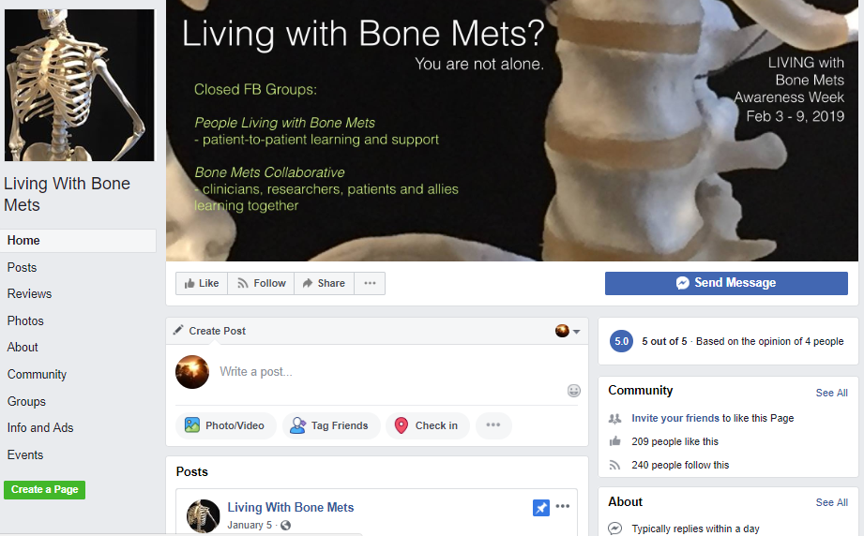





References & Resources
- Macedo, F., Ladeira, K., Pinho, F., Saraiva, N., Bonito, N., Pinto, L., & Gonçalves, F. (2017). Bone metastases: an overview. Oncology reviews, 11(1).
- Brodowicz, T., Hadji, P., Niepel, D., &Diel, I. (2017). Early identification and intervention matters: A comprehensive review of current evidence and recommendations for the monitoring of bone health in patients with cancer. Cancer treatment reviews.
- Downey, S.E., Wilson, M., Boggis, C., Baildam, A.D., Howell, A., & Bundred, N.J. (1997). Magnetic resonance imaging of bone metastases: a diagnostic and screening technique. British hournal of surgery, 84(8), 1093-1094.
- Traill, Z., Talbot, D., Golding, S., & Gleeson, F.V. (1999). Magnetic resonance imaging versus radionuclide scintigraphy in screening for bone metastases. Clinical radiology, 54(7), 448-451.
- American Cancer Society. (2016). Understanding bone metastasis. Retrieved from http://www.cancer.org/treatment/understandingyourdiagnosis/bonemetastasis/bonemetastasis-what-is-bone-mets
- American Society For Radiation Oncology (ASTRO). (2013). Radiation therapy for metastases to the bone. Retrieved from http://rtanswers.org/uploadedFiles/Treatment_Information/Brochures/BoneMetsBrochur.pdf
Author: Marize Ibrahim MSc, PT, CDT (CS)

