

Lung Cancer

Lung cancer accounts for approximately 13% of all cancers. Most lung cancers are caused by smoking and develop in men aged 65-74. There are two main types of lung cancer, small and non-small lung cancer. Each have their own subtypes.
Cancer that has developed in other parts of the body can spread to the lungs. This is referred to as lung metastasis. These are not considered to be primary lung cancer and therefore, are not treated the same way.

What Risk Factors cause this Cancer?
- Smoking tobacco or second-hand smoke exposure
- Radon and/or asbestos exposure
- Occupational exposure to asbestos, chromium, nickel, beryllium, arsenic, soot, or tar
- Exposure to outdoor air pollution or pollutants from cooking and heating
- Personal or family history of lung cancer
- Exposure to radiation
- Weakened immune system, specifically HIV, AIDS, or lupus
- Taking beta carotene supplements and being a heavy smoker

What are the Clinical Manifestations?
- Chest discomfort or pain
- A cough that does not go away or gets worse with time
- Shortness of breath/difficulty breathing
- Wheezing
- Blood in the sputum
- Hoarseness
- Loss of appetite and unexplained weight loss
- Feeling tired or fatigued
- Difficulty swallowing
- Swelling in the face and/or the veins of the neck

What are the Treatment Options?
Each case is unique and requires a personalized medical treatment plan. Some of the treatment options may include:

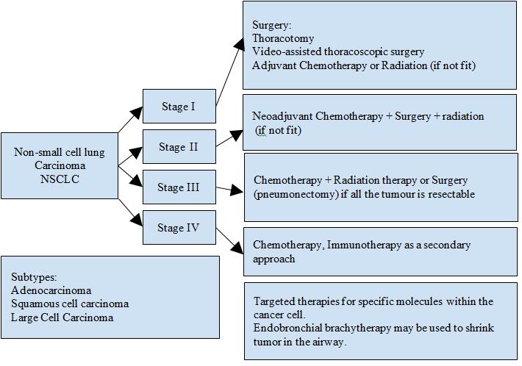

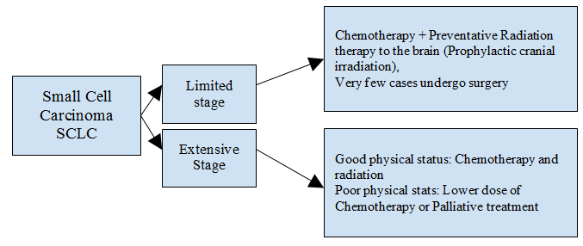

What are the Possible Side Effects of Treatment?
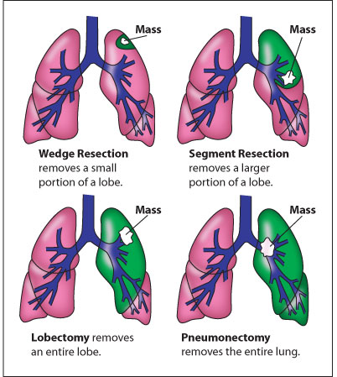
1) Surgery:
- Shoulder pain
- Shoulder movement restriction
- Upper extremity weakness
- Upper extremity lymphedema
- Neurological dysfunction
- Muscle instability and weakness
- Dehiscence, lymphocele, hematoma
2) Radiation Therapy:
- Fatigue
- Skin irritation
- Pain in the chest wall, axilla and surrounding tissues
- Reduced shoulder range of motion
- Radiation fibrosis
3) Chemotherapy:
- Fatigue
- Nausea/vomiting
- Neuropathy
- Menstrual changes
- Arthralgia
- Alopecia
- Mucous membranes irritation (e.g vulvar/vaginal tissues, vocal cords)
4) Hormonal Therapy:
- Menopausal-like symptoms (e.g. hot flashes, mood swings)
- Bone density loss (increased risk of osteopenia/osteoporosis)
- Weight gain
- Bowl irregularity
- Nausea
- Arthralgia
- Fatigue

What is the Role of Physiotherapy and Rehab?
The goals of rehabilitation depend on the extent of the disease, and the treatment patient is receiving over three distinct time periods: pre-operative, perioperative and post-operative.

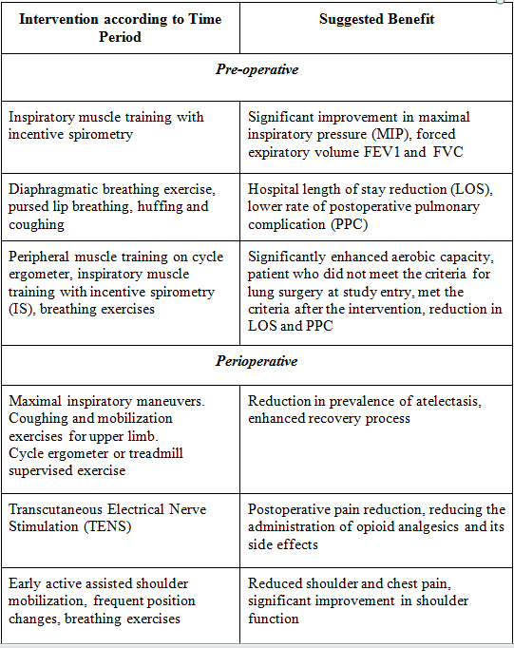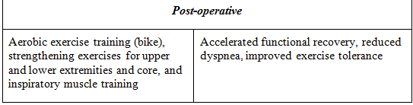

References & Resources
- National Cancer Institute: https://www.cancer.gov/types/brain
- Canadian Cancer Society: http://www.cancer.ca/en/?region=on
- Granger CL. Physiotherapy management of lung cancer. Journal of Physiotherapy. 2016; 62: 60-7
- Cavalheri V, Granger C. Preoperative exercise training for patients with non-small cell lung cancer. Cochrane Databases of Systematic Reviews. 2017; 6: 1-39
- Fouladbakhsh, J. M., Davis, J. E., & Yarandi, H. N. (2014). A pilot study of the feasibility and outcomes of yoga for lung cancer survivors. Oncology Nursing Forum, 41(2), 162–74. https://doi.org/10.1188/14.ONF.162-174
- Heywood, R., McCarthy, A. L., & Skinner, T. L. (2017). Safety and feasibility of exercise interventions in patients with advanced cancer: a systematic review. Supportive Care in Cancer, 1–20. https://doi.org/10.1007/s00520-017-3827-0
- Kendall, F., Abreu, P., Pinho, P., Oliveira, J., & Bastos, P. (2017). The role of physiotherapy in patients undergoing pulmonary surgery for lung cancer. A literature review. Revista Portuguesa de Pneumologia (English Edition). https://doi.org/10.1016/j.rppnen.2017.05.003
- Milbury, K., Chaoul, A., Engle, R., Liao, Z., Yang, C., Carmack, C., … Cohen, L. (2015). Couple-based Tibetan yoga program for lung cancer patients and their caregivers. Psycho-Oncology, 24(1), 117–20. https://doi.org/10.1002/pon.3588
- Milbury, K., Mallaiah, S., Lopez, G., Liao, Z., Yang, C., Carmack, C., … Cohen, L. (2016). Vivekananda Yoga Program for Patients With Advanced Lung Cancer and Their Family Caregivers, 10–15. https://doi.org/10.1177/1534735415583554
- Peddle-McIntyre, C. J., Bell, G., Fenton, D., McCargar, L., & Courneya, K. S. (2012). Feasibility and preliminary efficacy of progressive resistance exercise training in lung cancer survivors. Lung Cancer, 75(1), 126–132. https://doi.org/10.1016/j.lungcan.2011.05.026

Author: Alicia Page, MSc PT Candidate, Shreya Rewar, BSc PT,
Marize Ibrahim, MSc PT, CSLT.

